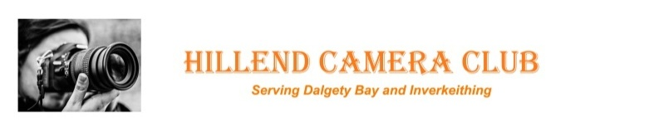  Membership Application and Data Protection Compliance  You are advised that the club needs to maintain a record of membership that will include name, email, address phone no. and information relating to attendance and subscription. The information will not be shared out-with the bounds of the club committee but may be used by those organising courses, competitions or mailing.  Name:  Address:  Contact number:  E-Mail Address:  I hereby apply for membership and give my permission for this information to be recorded for the purpose of maintaining club records etc the permission will remain valid for the duration of my membership of the club.  I agree to pay £40 Annual Membership for 2025-26 (expires 31st July 26) **accompanied children (12-16) free. **  Please tick √  This Club is affiliated to the Scottish Photographic Federation (SPF) | I further consent to my name, email and telephone number(s) being held on the website for members only access (password protected)  Please tick √  Optional confidential information:  D.O.B?  What camera do you use?  Do you need mentoring support?  Are you able to help with peer mentoring?  Would you consider standing for a committee post?  Do you have any special requirements or needs?  When on photoshoots is there anything we need to know in supporting you?  Forms received by email will be regarded as an electronic signature for the purpose of consent. (Data Protection)  Signature required for forms not sent electronically  Signed ……………………………………………………………………….……
  I will pay by bank transfer to
  RBS account - Hillend Camera Club 00128475 sort code 83-15-08
  I will pay by Cheque payable to Hillend Camera Club
  Cash payments or cheques can be handed to the Treasurer on a club night.

